**News Group**

**Problem Statement (Full Stack – UI, Service + CI/CD)**  
  
Develop, Test and Deploy a News Search Micro Service to the cloud, to find relevant news for a particular keyword (Ex: “apple”). Group the results in buckets based on ‘publishedAt’ date intervals (last N minutes, hours, days, weeks, months, years) specified by the inputs – N & Interval; Apply defaults of 12 hour intervals in case the optional input is empty or not provided. Use the ‘Everything’ API from NewsAPI.  
• End user should be able to view results by changing the input parameters  
• The service should be ready to be released to production or live environment  
• The service should be accessible via web browser or postman (using any one of JavaScript frameworks, HTML or JSON)  
• The solution should support offline mode with toggles  
• The service should return relevant results as expected, even while the underlying dependencies (Ex: Public API) are not available!  
(Use your own code/logic/data structures and without 3rd party libraries or DB)  
  
**API Data Sources**   
**API**: <a href="https://newsapi.org/docs/endpoints/everything" target="_blank">https://newsapi.org/docs/endpoints/everything</a>   
**Key**: ccaf5d41cc5140c984818c344edcc14d  
(Feel free to register your own, in case of any hiccups)  
  
**Expected output**   
(via an UI mechanism of your choice – Ex: React page)  
Interval group  
Count of entries in each group  
List of entries within each group  
  
**NFRs**   
• Demonstrate SOLID, 12 Factor and HATEOAS principles, Design Patterns in the design and implementation  
• Demonstrate Performance, Optimization & Security aspects  
• Demonstrate Production readiness of the code  
• Demonstrate TDD & BDD & Quality aspects  
• Demonstrate sensitive information used in the Micro Services such as API keys are protected / encrypted  
  
**Documentation**   
• Include the open-API spec./Swagger to be part of the code. Should be able to view API via swagger (Documentation to explain the purpose of the API along with Error codes that the service consumers & client must be aware of!)  
• Create a README.md file in the repository and explain the design and implementation approach  
• In the README, add a sequence diagram or flowchart created using draw.io – https://www.draw.io  
• Mention the design patterns used in the code  
  
**Build & Deploy**   
CI  
• Build CI/CD pipeline for your project(s); Pipeline scripts need to be part of the codebase;  
• Ensure the Jenkins job config., scripts are a part of the project sources  
CD  
• Demonstrate the service deployment using a Docker container (Create a docker image and publish service locally)  
• Ensure the docker files are a part of the project sources  
  
**Instructions reg. IDE**   
  
• Only 8080 port is available on preview panel. Configure your application on 8080 port only.  
• If QuizME is not accessible for full length coding due to network/bandwidth or any other constraints, please:  
1. Share a screenshot of the issue you are facing  
2. Use your local system & favorite IDE for Development and Testing, and for submission.  
3. Upload the project files to QuizME (using the “Upload Files” option in QuizME)  
OR  
Share the sources as a zip file along with the executable uber jar with all dependencies to HR

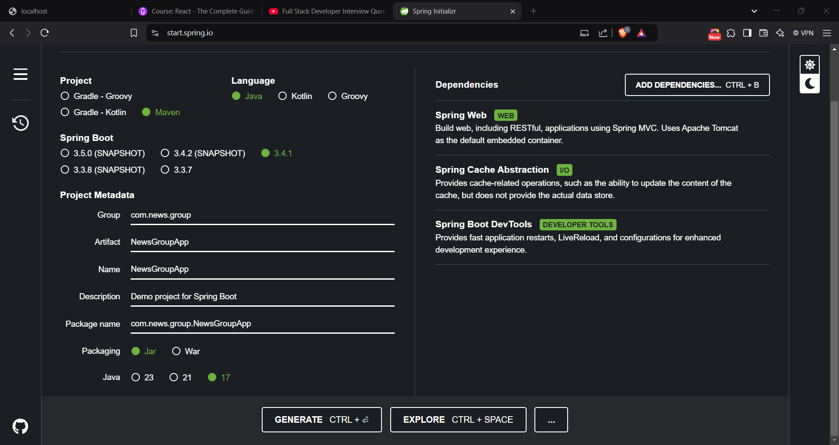

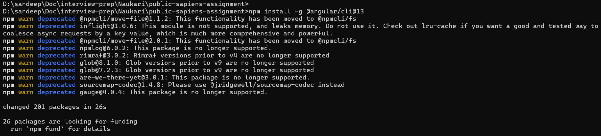

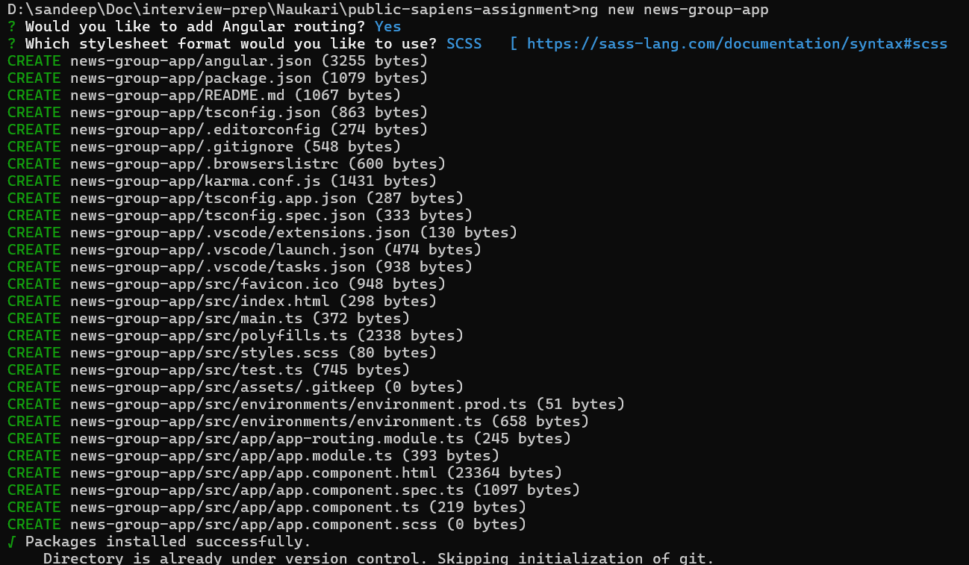

Frontend Successful:

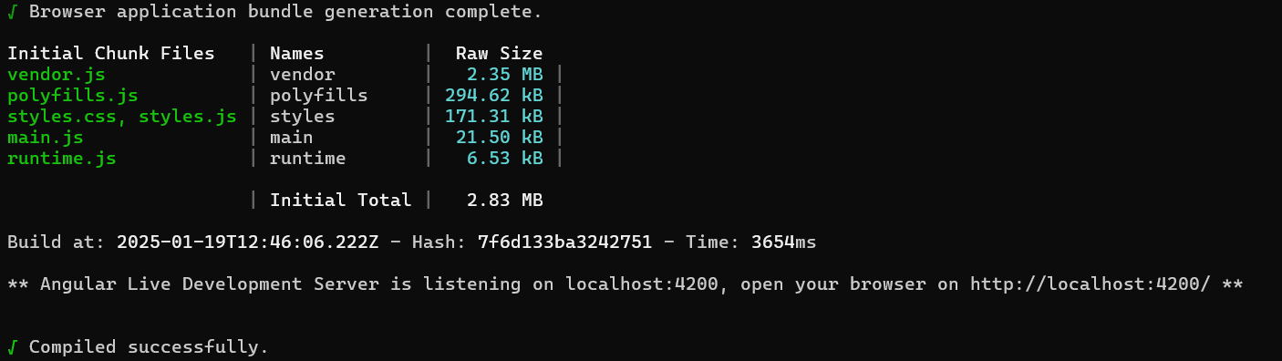

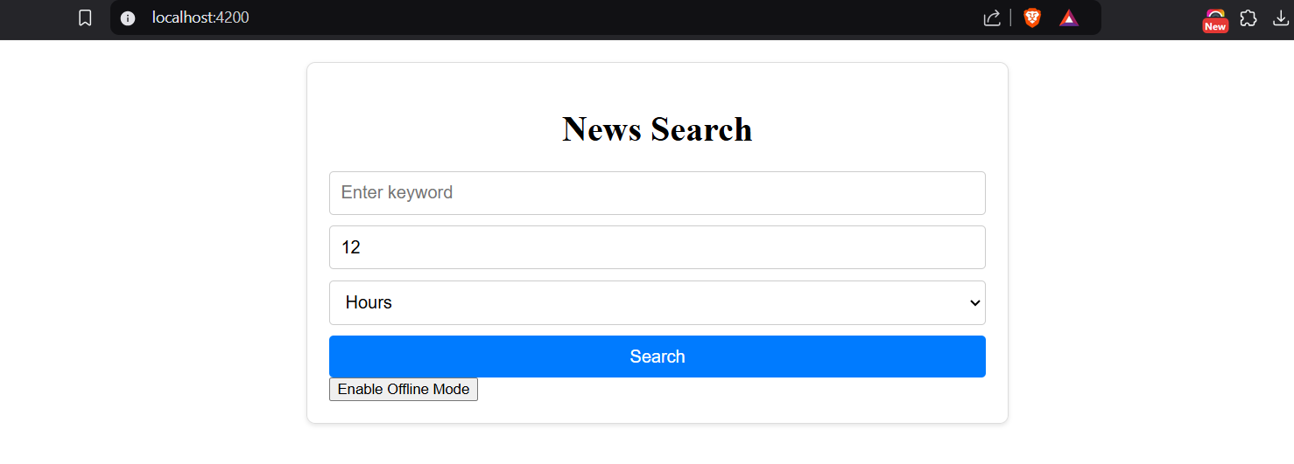

1.Build the Frontend Docker image:

docker build -t news-frontend .

2. Run the container:

docker run -p 80:80 news-frontend

Backend Successful:

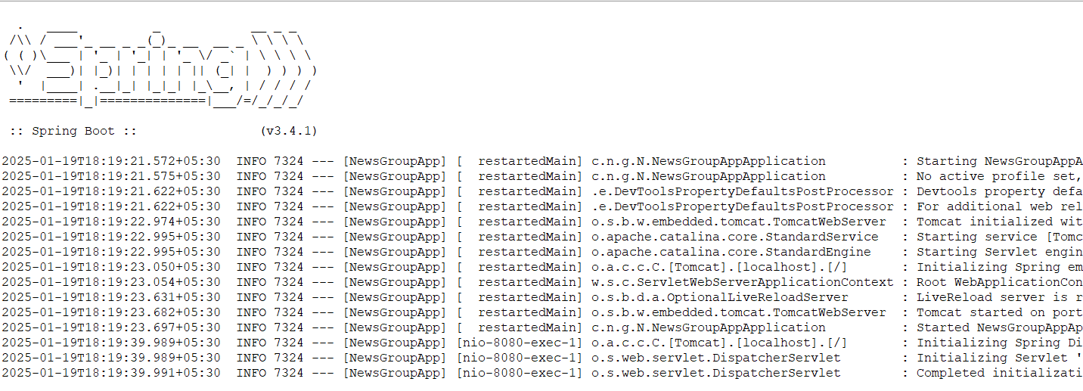

1 .Build your Spring Boot application:

mvn clean package

2. Build the Docker image:

docker build -t news-backend .

3. Run the container:

docker run -p 8080:8080 news-backend